**PRINCE MOHAMMAD BIN FAHD UNIVERSITY**

**College of Computer Engineering and Sciences**

**SENIOR DESIGN PROJECT**

**Date of submission**: 12th May 2022

AbuMuhammad Moinuddeen – 201801550 – IT Major

Ahmed Abul Hasanaath – 201900174 – CS Major

Table of Contents

Introduction 3

Justification 3

Detailed Requirements 3

Mobile App Functional Requirements 4

Web App Functional Requirements 4

Server Functional Requirements 4

System Mock Up 5

Security Requirements 7

Other Non-Functional requirement 7

Risk Assessment 8

Standards 9

High Level Architecture 9

Tools and Processes 9

Hardware Tools 9

Software Tools 9

Process 10

Project Plan 10

Sub-Team Responsibilities and Team Structure 10

Expected Results 11

Reference 11

# Introduction

The aim of this project is to create road maintenance management system. The goal is to employ machine learning techniques to categorize our roads into 4 different classes based on their quality: good, medium, bad and unpaved. As all machine learning projects go, our team will attempt to generate a dataset that properly represents the roads of Saudi Arabia. We will then train a machine learning model that can accurately classify the roads into the aforementioned categories. Finally, we will create a system that commissions the model to assess the roads of Saudi Arabia and displays the result on a map. The proposed system is largely beneficial to anyone that uses a road in their daily lives, i.e., everyone.

## Justification

The overarching reason to work on this project is its sheer amount of benefit. The completed system has various applications. It is useful to the common man in their daily lives, to government authorities in their operations, and is also a great research topic that advances the conversation on how artificial intelligence can make our lives easier.

Roads are an essential part of our lives. Without them, transportation as we know it will pretty much cease to exist. It helps if we have systems in place that help us use our roads more efficiently. Our proposed project does exactly that. One of the main uses of our system is in navigation applications. Classifying roads and assigning weights to them can help navigation applications in determining the best route. The obvious benefit of efficient transportation is that it saves both time and money. There are many more not so obvious benefits that are beyond the scope of a proposal.

Our project can prove to be useful to government authorities. Having information on the quality of roads can help with maintenance.

Finally, this project can be expanded into a very interesting and beneficial research topic. It helps in advancing the conversation on the importance of Artificial Intelligence in the 21st century. Regardless of whether or not the system is implemented and deployed, attempting this project answers a lot of questions and helps us understand the science of Artificial Intelligence better.

# Detailed Requirements

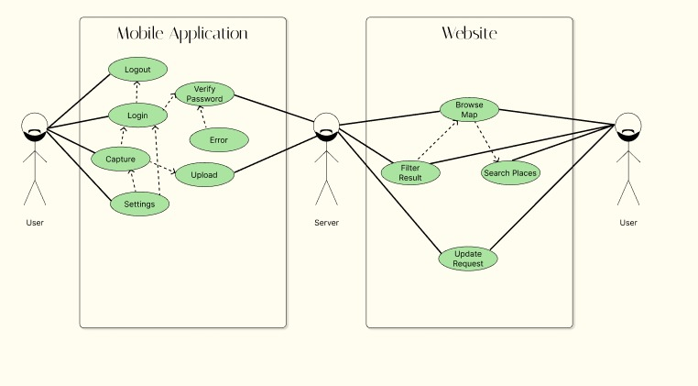

The main major requirements are as follows:

* Data collection and Processing
* Development of the Machine Learning Model
* Development of mobile and web application
* Integration of software and hardware components

## Mobile App Functional Requirements

* The application requires the user to enter their credentials when they first open the application.
* The application authenticates and then logs the user in after valid credentials are entered.
* The application should have a password recovery feature.
* The application prompts the user to enter their email when the user uses the password recovery feature.
* The system sends a password recovery email to the user’s email address.
* Each time the user successfully logs in, the user is instructed on how to use the application.
* The user can disable the instructions from popping up each time they log in.
* When the user chooses to start collecting data the system will prompt the user to select the rate at which the photos will be taken.
* The application will classify the images locally and upload the classification along with a geotag, time and user ID.
* In case internet connection is not available, the application will store the collected data locally, until connection is established again.
* The device should work with both mobile data and a Wi-Fi connection.

## Web App Functional Requirements

* The website should display a map that displays the road quality as pointers. The pins should have different colors that represent the condition of the road. Green for good, yellow for medium, red for bad and purple for unpaved.
* The website interface should contain filter options for filtering how the road quality data is displayed. The user should be able to filter by road name, city name, geolocation and road quality.
* The website should contain a password protected form for administrators that allows them to update or delete entries in the database. There should also be a form that allows for adding, updating or deleting user information.

## Server Functional Requirements

* The server will handle GET and POST requests from the mobile app as well as the web app.
* The server will receive POST request from mobile application containing road data (classification, geotag, time, user ID).
* The server will receive POST request from web application in regards to adding, deleting or updating user and/or road data.
* The server will send road quality data to the web application when dashboard is accessed.

## System Mock Up

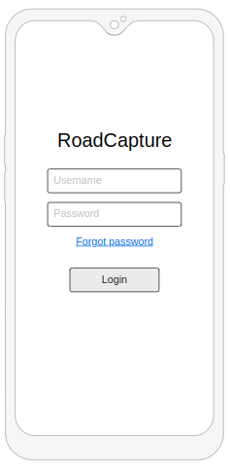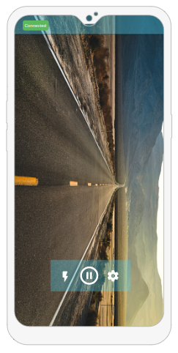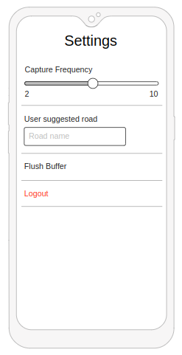**Mobile Application**:

**Fig. 1:** Login Page

**Fig. 2:** Main Page

**Fig. 3:** Settings Page

**Website**:

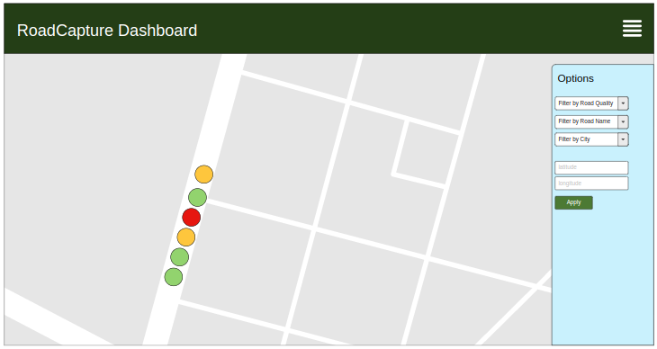

**Fig. 1:** Website Dashboard

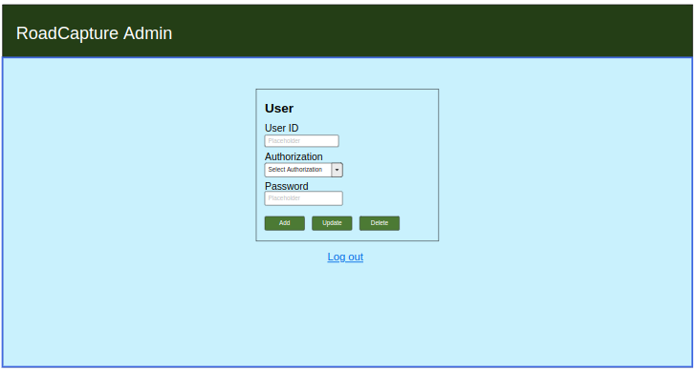

**Fig. 2:** Admin page for user data

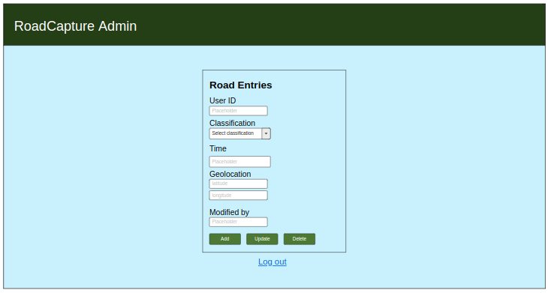

**Fig. 3:** Admin page for road data

## Security Requirements

* **User Authorization and Authentication**: for accessing application features.
* **Password Constraints**: 8 characters long and should contain at least 1 special character and 1 number.
* **Password Hiding**: in HTML/UI form and through hashed password sent to the server.

## Other Non-Functional requirement

**Constraint Table**

|  |  |  |
| --- | --- | --- |
| **Constraint Number** | **Constraint Type** | **Constraint Description** |
| C.1 | Technical Constraint (Reliability, Performance, Usability,  Supportability) | **Mobile App Constraints:**   * The application should account for unavailable internet connection. * The application should make sure the geotag is within the borders of the road. * The mobile app should reliably send POST requests to the server and should account for image capture delay. * The mobile app should work on all mobile devices with Android 9 or higher and iOS 9 or higher. * The mobile app should work on all mobile devices with camera resolution greater than 5MP. * The application will give the user the option to change the language between Arabic and English,   **Web App Constraints:**   * System should not fail if user input is invalid. * System should handle session timeouts properly. * The website should work seamlessly on all devices with screen resolution greater than 480x800 pixels.   **Server Constraints:**   * The server should respond to GET requests in less than 2 seconds. * The server should validate all data received through POST requests before eliciting a response. |
| C.2 | Project Management Constraints | * The system should be complete within 4 months' time * Team members will be trained with required background knowledge on Machine Learning, Web Development and Mobile App Development. |
| C.3 | Environmental Constraints | * The vehicle used for data collection should meet environment safety standards. |
| C.4 | Safety Constraints | * The mobile device should be securely mounted to the vehicle in order to prevent device loss. * The vehicle should be operated by licensed drivers. |

## Risk Assessment

|  |  |  |
| --- | --- | --- |
| **Risk(s)** | **Potential Impact** | **Risk Mitigation** |
| Unauthorized access by intruders. | System functionality will be compromised. | * Provide stronger authentication and authorization. |
| Mobile device mounted on vehicle may fall off | Equipment loss and compromised operation. | * Ensure secure mounting of device. |
| Camera on mobile device may get damage due to flying debris such as large dust particles and bugs. | System functionality will be affected negatively. | * Attach clear transparent shield to the camera and regularly change it. |
| Vehicle driver may get distracted. | Health hazard and equipment damage. | * Ensure driver has license. * Driver should have company that helps with everything other than driving. |

## Standards

* **NIST (National Institute of Standards and Technology) standard 'FIPS 180-4'**: use of SHA-256 for hashing passwords.

# High Level Architecture

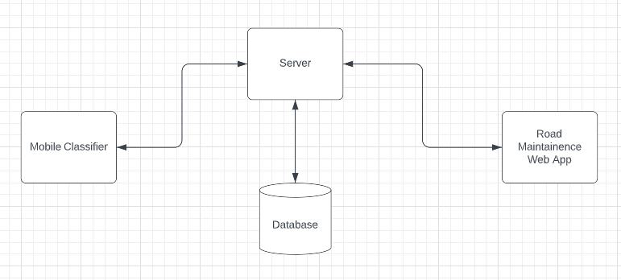

A machine learning will be loaded onto a smartphone. The mobile device will be mounted on a vehicle. The device will collect images of roads and classify them into 3 different categories. The device will geo-tag each classification and upload the information to a server. The server will store the data in a database. The data can be used in various applications. Our goal is to build a Road Maintenance Management system. The system will display the classification data of on a map, helping the concerned authorities in maintaining roads.

# Tools and Processes

## Hardware Tools

**Smartphone**. Any smartphone running Android 9/iOS 9 or higher and with camera resolution greater than 5MP should be fine.

## Software Tools

**Flask**. We will use Flask to build our server functionalities. The main reason we chose Flask was because it's a Python based framework. We preferred a python-based framework because given it is easier to work with, given our requirements.

**React Native**. We will use React Native to build our mobile application. We chose React Native because it hit the best balance between ease of use and functionality.

**TensorFlow**. We will use the TensorFlow library to train a deep learning model. The TensorFlow library is incredibly competent and super intuitive to use, making it the perfect choice for our project.

**OpenCV**. The OpenCV library will be very useful in image processing. We chose this library because it is widely used and there were no other comparable options.

## Process

We will first attempt to train a model that can accurately classify images of roads. We will then build a server that is responsible for receiving the data, storing it, and sending it to the authorized requests. After that, we will build the mobile application responsible for sending geo-tagged classifications to the server. Finally, we will build the web application that displays the information on a map.

# Project Plan

We will first attempt to train a model that can accurately classify images of roads. We will then build a server that is responsible for receiving the data, storing it, and sending it to the authorized requests. After that, we will build the mobile application responsible for sending geo-tagged classifications to the server. Finally, we will make the web application that displays the information on a map.

**Week 1.** Problem Identification and Requirement Analysis

**Week 2.** Process Identification and Initial Design

**Week 3.** Timeline planning and work distribution

**Week 4-5.** Data gathering, cleaning and processing

**Week 6.** Building an initial ML model

**Week 7.** Setting up a server

**Week 8**. Building the web and mobile app

**Week 9**. Building the web and mobile app cont.

**Week 10.** Attempt to improve ML model accuracy

**Week 11.** Rigorous testing

**Week 12.** Finalizing and presenting demos

**Week 13.** Final project report and presentation

## Sub-Team Responsibilities and Team Structure

Team management is a large part of working on a project. Following is a list of each member, their expertise and their responsibilities.

**Abumuhammad Moinuddeen (Team Leader)**

* Expertise
  + Python programming
  + Data processing
  + ML
* Responsibilities
  + Project management
  + UI Design
  + Collaboration on building the ML model

**Ahmed Abul Hasanaath**

* Expertise
  + Web Programming
  + Mobile Application Development
  + ML
* Responsibilities
  + Building a road classifier application on a smartphone
  + Building the road maintenance management system web application
  + Collaboration on building the ML model

# Expected Results

We want to build a fully functional system. However, our limitations as undergrad students hold us back in a few areas. Data collection is difficult and we might not be able to collect a dataset that fully represents the roads of Saudi Arabia. As a consequence, our ML model may not be able to give accurate classifications in unideal conditions. However, we are confident that our system will do well in representing what can be if we could somehow alleviate our limitations. Our system will also do well in laying the foundations for future improvements. Overall, the project will be worth doing as it is a great learning experience.

# Reference

<https://www.tutorialspoint.com/react_native/index.htm>

<https://deeplizard.com/courses>

<https://www.tutorialspoint.comhttps://www.tutorialspoint.com/flask/index.htm/opencv/index.htm>

<https://www.tutorialspoint.com/flask/index.htm>